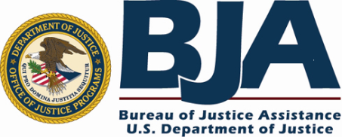 

**Attention: Judges, Coordinators, Treatment Providers, and Others Working with Drug Court Programs**

The **BJA Drug Court Technical Assistance Project at American University** will conduct an interactive webinar on **Wednesday, January 29th from 3:00 – 4:30 p.m. EST** focusing on the special challenges encountered by drug courts and their treatment providers in rural and frontier areas of the country and responses that have proven affective. This webinar will also draw on a *Technical Assistance Guide* *on Drug Court Treatment Services* developed through the BJA Drug Court Technical Assistance Project soon to be published.

The webinar panelists will consist of drug court practitioners with many years of experience working in rural areas of the country: Judge Katherine Bidegaray from Sidney, Montana; Judge Phil Britt from Kennet, Missouri; Marilyn Kesner, Drug Court Coordinator from Sandpoint, Idaho; and Angela Plunkett, Statewide Drug Court Coordinator from Missouri. Jeffrey Kushner, Statewide Coordinator from Montana, will facilitate the session.

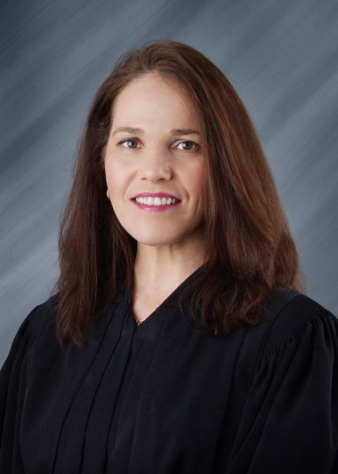 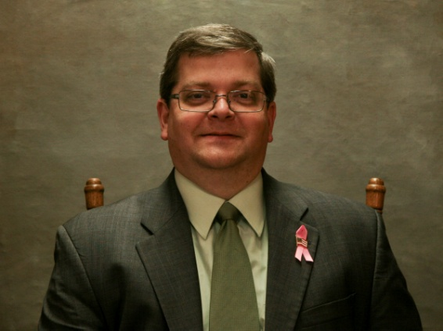  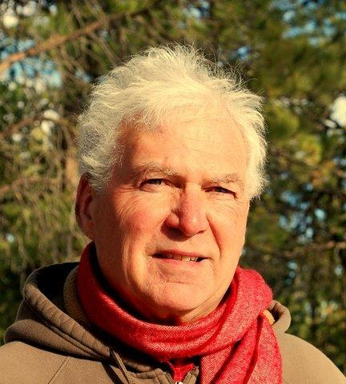 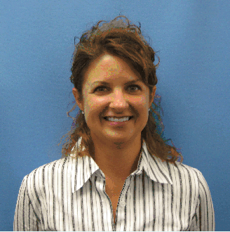

**Hon. Katherine Bidegaray Judge Phil Britt Marilyn Kesner Jeffrey Kushner Angela Plunkett**

The webinar will highlight ten common challenges rural Drug Court programs encounter

1. Lack of treatment capacity, lack of access to a full continuum of treatment services and inconsistency of treatment services
2. Lack of access to adequate wrap around services for drug court participants (employment services, vocational rehabilitation services, medical and dental services, daycare, etc.)
3. Lack of alcohol and drug free housing for drug court participants
4. Lack of transportation for drug court participants who are unable to get to treatment and/or meetings, work, and/or school
5. Inability of drug court treatment provider to find and hire qualified staff and avoid excessive turnover
6. Resources for addressing family drug use that is prevalent for many drug court participants
7. Inability of the drug court judges and/or drug court team members to cover expansive geographic rural area in order to hold the frequent status hearings necessary to adequately monitor program participation
8. Assuring confidentiality of information regarding drug court participants’ involvement in treatment, mutual aid attendance (AA, NA, meetings) and other treatment related activities in a rural setting)
9. Providing adequate training for drug court team members; and
10. Conducting random alcohol and other drug testing at a reasonable cost that conforms with evidence based practices

The webinar is planned to be interactive with attendees invited to submit their questions in advance and during the session. If you are not able to participate in the live session, the slides and recording of the webinar will be made available shortly after the webinar and archived at <http://www.american.edu/spa/jpo>.

Caroline S. Cooper

Director, BJA Drug Court Technical Assistance Project, American University, Washington D.C.

Enclosure: Webinar Agenda: **January 29, 2014**: 3:00 – 4:30 p.m. Eastern Time